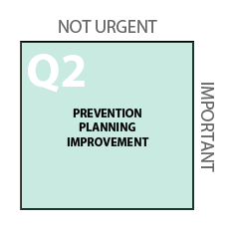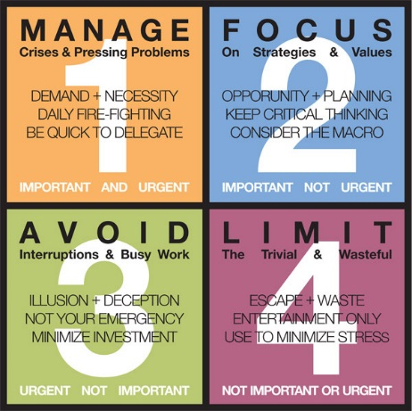

Date | Activity
Ongoing | Ensuring each student is well known by at least one adult advocate at the school should become part of the continuous improvement planning process and be specifically included in future School Strategic Plans.

Our School’s Wildly Important Goal: Ideas:
To go from _____ students who do not identify an advocate to ____ by June 2016.
To go from ____ students at ________ grade who do not identify an advocate to _____ by June 2016.
Or your own…
___________________________________________________________________________________

My Big Bet or Our School’s Next Steps:
If we do the following things, we will see the greatest gains as we seek to help students who do not identify an advocate:

Challenge: Can you make you Goal SMART?

