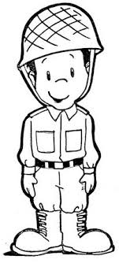
I am a Military Child… 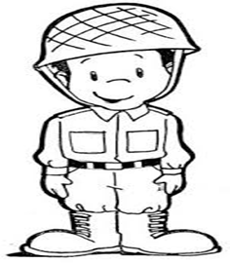
___________________________________________________________________________________________
___________________________________________________________________________________________
___________________________________________________________________________________________
___________________________________________________________________________________________
___________________________________________________________________________________________
___________________________________________________________________________________________
___________________________________________________________________________________________
___________________________________________________________________________________________
___________________________________________________________________________________________
___________________________________________________________________________________________
___________________________________________________________________________________________
___________________________________________________________________________________________
___________________________________________________________________________________________
___________________________________________________________________________________________
___________________________________________________________________________________________
___________________________________________________________________________________________
___________________________________________________________________________________________
___________________________________________________________________________________________
___________________________________________________________________________________________
___________________________________________________________________________________________
___________________________________________________________________________________________

BY:________________________________________

